**Software Architecture: Requirement & Design**

**CS 457**

**Assignment-2**

Submitted by

Teja Garidepally (9)

Raj Kiran Reddy Munnangi(26)

Suhas Sai Raparthi(32)

Hakami Faisal Hassan A(13)

**Use case 1: Vote for your future:**

1. **Use case Diagram: The diagram shows different activities of the system along with the actors associated with them.**

C:\Users\LENOVO\Desktop\Use case Diagram.png

1. **Class Diagram: The diagram represents the structure of the system in terms of objects, classes, attributes, operations and associations.**

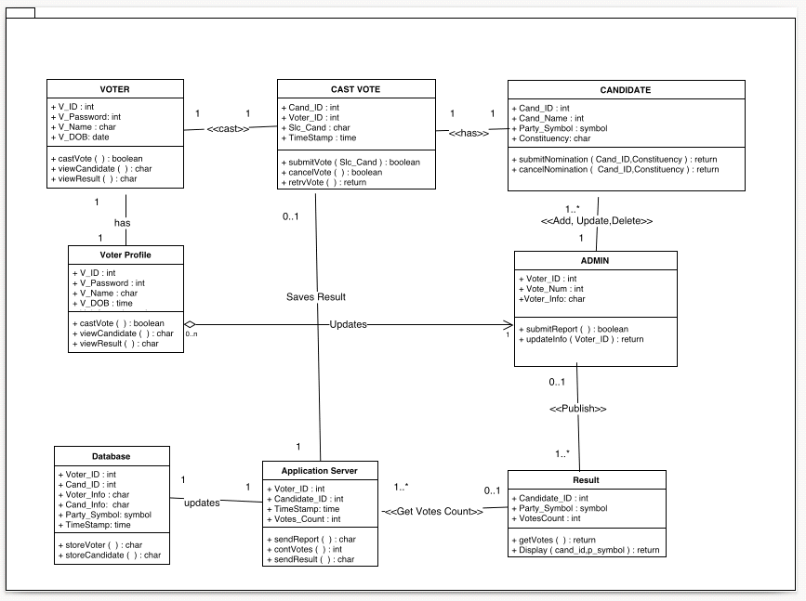

1. **Activity Diagram: An activity diagram represents all main activities of the entire project.**

* **User diagram:**

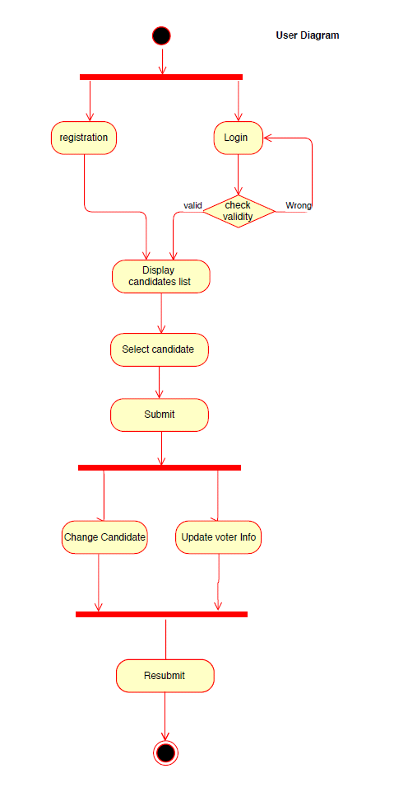

* **Admin diagram:**

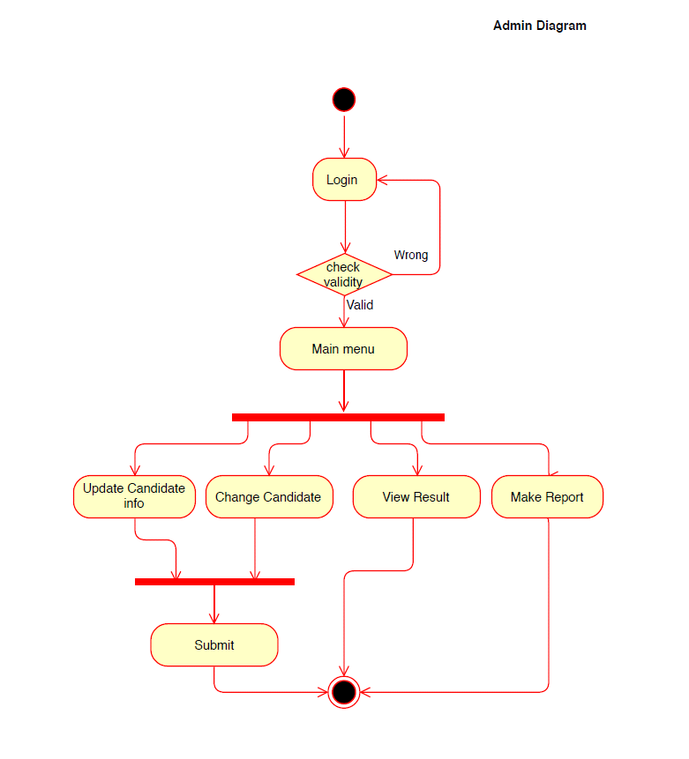

1. **Sequence Diagram: The diagram shows the interaction between objects in a system and also specify in which way those interactions happen.**

* **Voter registration: This diagram depicts how the voter registers and creates his profile.**

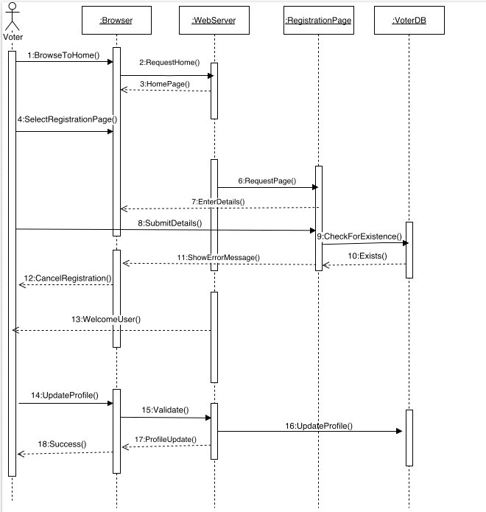

* **Voter provision: This diagram depicts how the voter logs into his account and casts his vote**

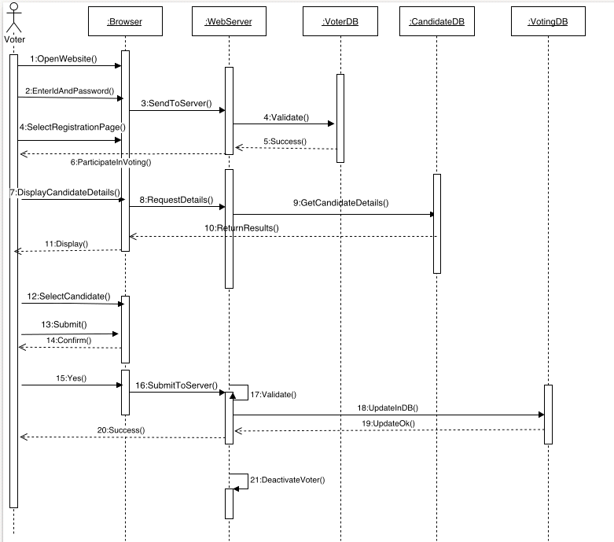

* **Vote Counting: This diagram depicts how the counting process takes place for declaring the results**

C:\Users\LENOVO\Desktop\Sequence_Diagram.png